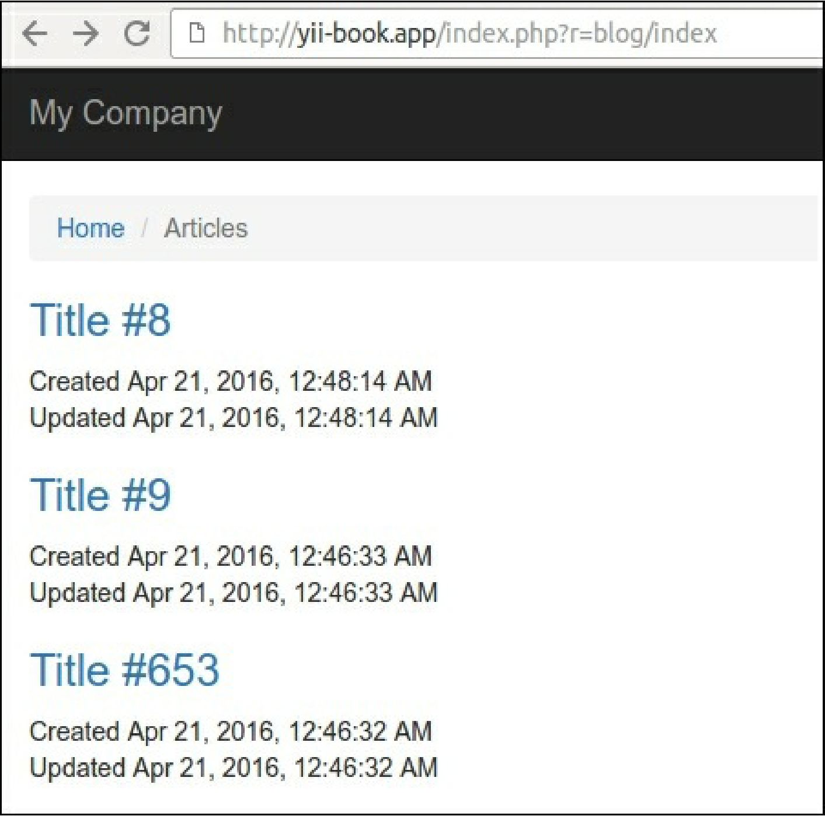

1. Open the developer console in your browser and see the 200 ok response status for each reloading of the blog page: